**Supply Power Electronics design board with Kicad**

1. **Reverse engineering schematic from 5v**
2. 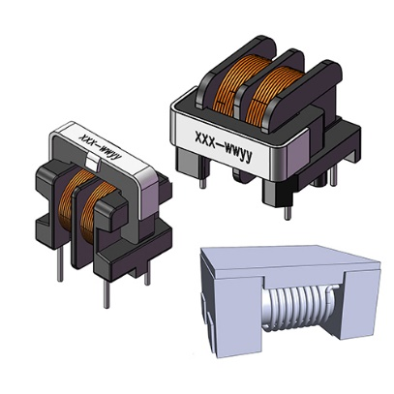 **common mode choke**

A [common mode choke](https://magnetic-components.mpsind.com/category/common-mode-chokes) is an electromagnetic component that blocks high frequencies by passing direct currents (DC) and alternating currents (AC) through an electrical circuit. The choke gets its name because it blocks or “chokes” high-frequency signals while low-frequency signals pass through.

1. 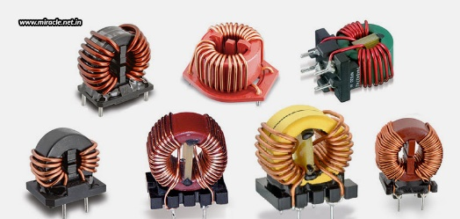**What Are Common Mode Chokes?**

Common mode chokes suppress electromagnetic interference (EMI) and radiofrequency current (RFI) from a power supply. EMI and RFI interference pose serious problems for electronic equipment, especially with a power-line communication system. Because common mode chokes protect equipment from frequency interference, they’ve become essential in the industrial, electrical, data-processing, manufacturing, and telecommunication sectors.

1. What Are the Advantages of Using Common Mode Chokes?

There are numerous advantages to using a common mode choke in an electrical circuit, including:

* Increased efficiency
* High inductance
* Low-EMI radiation
* Blocked or suppressed high-frequency signals Protect your
* USB applications with our high-speed data line common mode chokes

What is the difference between common mode and differential mode?

The common mode refers to signals or noise that flow in the same direction in a pair of lines.

The differential (normal) mode refers to signals or noise that flow in opposite directions in a pair of lines.  
  
As an example for convenience, consider a configuration where two copper wires are wound around a ring-shaped ferrite core. In this structure, two patterns may exist: one where the currents in the wires flow in the same direction, and another where they flow in opposite directions. These two patterns are “common mode” and “differential mode”.

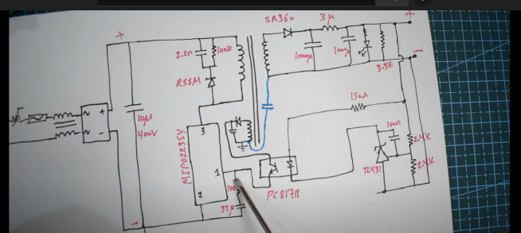**Note the current flow from high voltage to low voltage**

**explication of the important bloc of power supply**

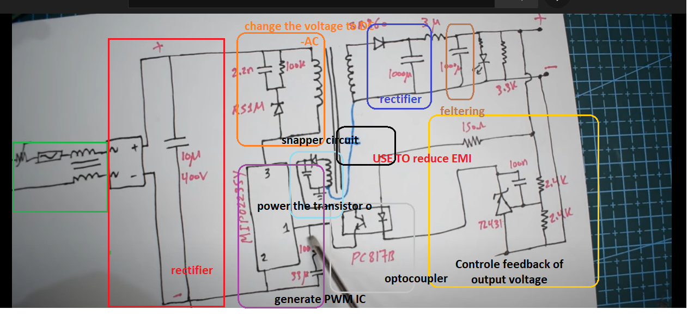

## What is a Buck Boost Converter?

The buck–boost converter is a type of DC-to-DC converter (also known as a [chopper](https://www.electrical4u.com/chopper-dc-to-dc-converter/)) that has an output [voltage](https://www.electrical4u.com/voltage-or-electric-potential-difference/) magnitude that is either greater than or less than the input voltage magnitude. It is used to “step up” the [DC voltage](https://www.electrical4u.com/dc-voltage/), similar to a [transformer](https://www.electrical4u.com/what-is-transformer-definition-working-principle-of-transformer/) for AC circuits.

It is equivalent to a flyback converter using a single inductor instead of a transformer. Two different topologies are called a buck-boost converters.

1. 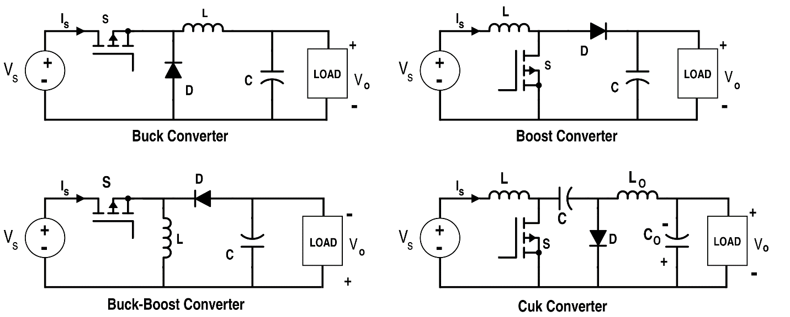types from DC-DC converters
2. **Example 2 DC-DC converter**

lm2576-adj datasheet pdf

What are concerns for a power supply PCB layout?

• Safety • EMI

• Parasitic inductance

• Parasitic capacitance

• Parasitic resistance

Zener snubber

Snubber circuit

RC snubber

RCD Snubber